 |  | Bath Community School
 | 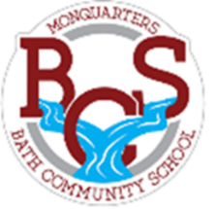  Monquarter Memo |  |  |  |  |  | Volume 1
Phone: 278-6000 Twitter: @BathMonquarters
Website: http://BCS.nbed.nb.ca/
WELCOME to the 2021-2022 school year at BCS!  The student fee this year is $21.25. This can be paid online or sent to school in student agendas.  Reminders:  Please make sure your student brings their agenda, 2 clean masks, and a water bottle each day.  Thank you!  School Lunch  Please purchase meals with School Cash Online by 3:00 pm the day before. The menu will be on a weekly rotation this year, which will be sent home soon!  Current menu  Monday:  Turkey Dinner & cookie  Tuesday:  Chicken Burger & carrot sticks  Wednesday:  Hot Dogs & chips  Thursday:  Pizza & garlic fingers  Friday:  Hamburger or Cheeseburger & cookie  Breakfast program  We are currently working to get our Breakfast Program up and going at BCS. If you have an interest in helping prepare breakfast or making a financial donation you can email Valerie Carmichael. valerie.carmichael@nbed.nb.ca |  |  |  |  | Upcoming Events  September 19th – Becca Schofield Day  Share a little kindness today in memory of Becca Schofield.  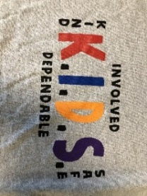  September 20th – Food Truck  The food truck is back at BCS to serve a hot dog or hamburger & fries to students – free of charge! So, no need to pack a lunch.  September 29th – Terry Fox Walk  BCS students and staff will participate in our annual  Terry Fox walk, please dress accordingly. Donations  can be made on School Cash Online; any donation is  appreciated.  We would love to have students join us in wearing  our K.I.D.S. t-shirts or school colors for this event!  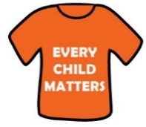  September 30th – National Day for Truth and Reconciliation  In solidarity with Indigenous peoples across Canada, we encourage staff and students to wear orange on this day to honour the Indigenous children who were taken from their families, and to be reminded of the continued strength and resilience of Indigenous peoples.  October 6th - Grade 7 HPV Immunization clinic  October 11th -Thanksgiving, no school  October 12th -Picture Day!  The school agendas say October 16th is picture  day– this is an error. Sorry, October 12th is the big day.
Parent School Support Committee (PSSC)
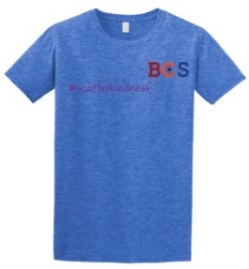
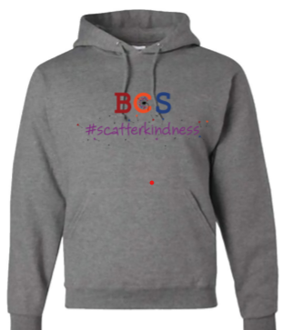
The role of PSSC is very important. The PSSC works with the Principal on school improvement, communication with the school community and the review/development of school policies. Please put your name forward to become a member of our 2021-2022 PSSC by emailing Mitchell @ Mitchell.Hemphill@nbed.nb.ca if you are interested in serving. We meet approximately five times a year.
School Swag is coming!
School t-shirts and sweatshirts
will be on sale later this month,
through School Cash Online.
Please look for order forms to
be sent home soon!

